**TUTELAGE APPLICATION PAHSE 2**

**VIGNESHWAARAR CR**

**(A20392185)**

**&**

**LAVANYA SURIKAPURAM**

**(A20392981)**

**ITMD 510**

**PROJECT PHASE – I**

**05/02/2017**

**Table of Contents**

DESCRIPTION OF THE PROJECT …………………………………………………………..……3

MAIN MENU FOR TUTELAGE APPLICATION …………………………………..…………3

TABLES USED …………………………………………………………………………..………………4

SCREEN SHOTS………………………………………………………………………………………….5

**DESCRIPTION OF PROJECT:**

This is an online tutoring web application. Users are to be registered to access this application.

Users who have registered can log in and request for classes on any course/stream in which they are interested. Hence the requested class will be considered by other user who can conduct that class online and decide based on the strength of the no of users requested that class/course and schedule the online class.

The application can be used by two users,

1. STUDENTS
2. PROFESSORS
3. ADMIN

Students can register as well as search or request for topics in which they wish to be tutored on. Any professor who has good experience or knowledge on the topics requested by students can consider their request and conduct classes online.

**MAIN MENU FOR TUTELAGE APPLICATION****:**

**1**.      **STUDENT PAGE**

a.      LOGIN

b.      CREATE PROFILE

c.      EDIT PROFILE

d.      VIEW CLASS REQUEST HISTORY

e.      REGISTER FOR CLASS

f.       VIEW REGISTERED CLASSES

g.      LOGOUT

**2**.      **PROFESSOR PAGE**

a.      LOGIN

b.      CREATE PROFILE

c.      EDIT PROFILE

d.      VIEW CLASS HISTORY

e.       ADD TOPICS

f.      LOGOUT

**3. ADMIN PAGE**

1. LOGIN
2. ADD TOPICS
3. SEARCH FOR CLASS AND CREATE REQUEST
4. VIEW THE REQUESTED CLASSES
5. UPDATE THE COURSE
6. DELETE THE COURSE
7. VIEW CLASS ENROLLMENTS
8. LOGOUT

**TABLES USED IN THE APP:**

* **tutelage_administrator**
* **tutelage_prof**
* **tutelage_Student**
* **tutelage_course**
* **tutelage_course_register**

**SNAPSHOTS:**

1. **MAIN LOGIN PAGES**
2. **ADMIN PAGES**
3. **PROFESSOR PAGES**
4. **STUDENT PAGES**
5. **ERROR/VALIDATION**
6. **MAIN PAGE:**

This enables the user to select any one mode of login



**LOGIN PAGE FOR EACH USER**

**1.1 ADMIN:**

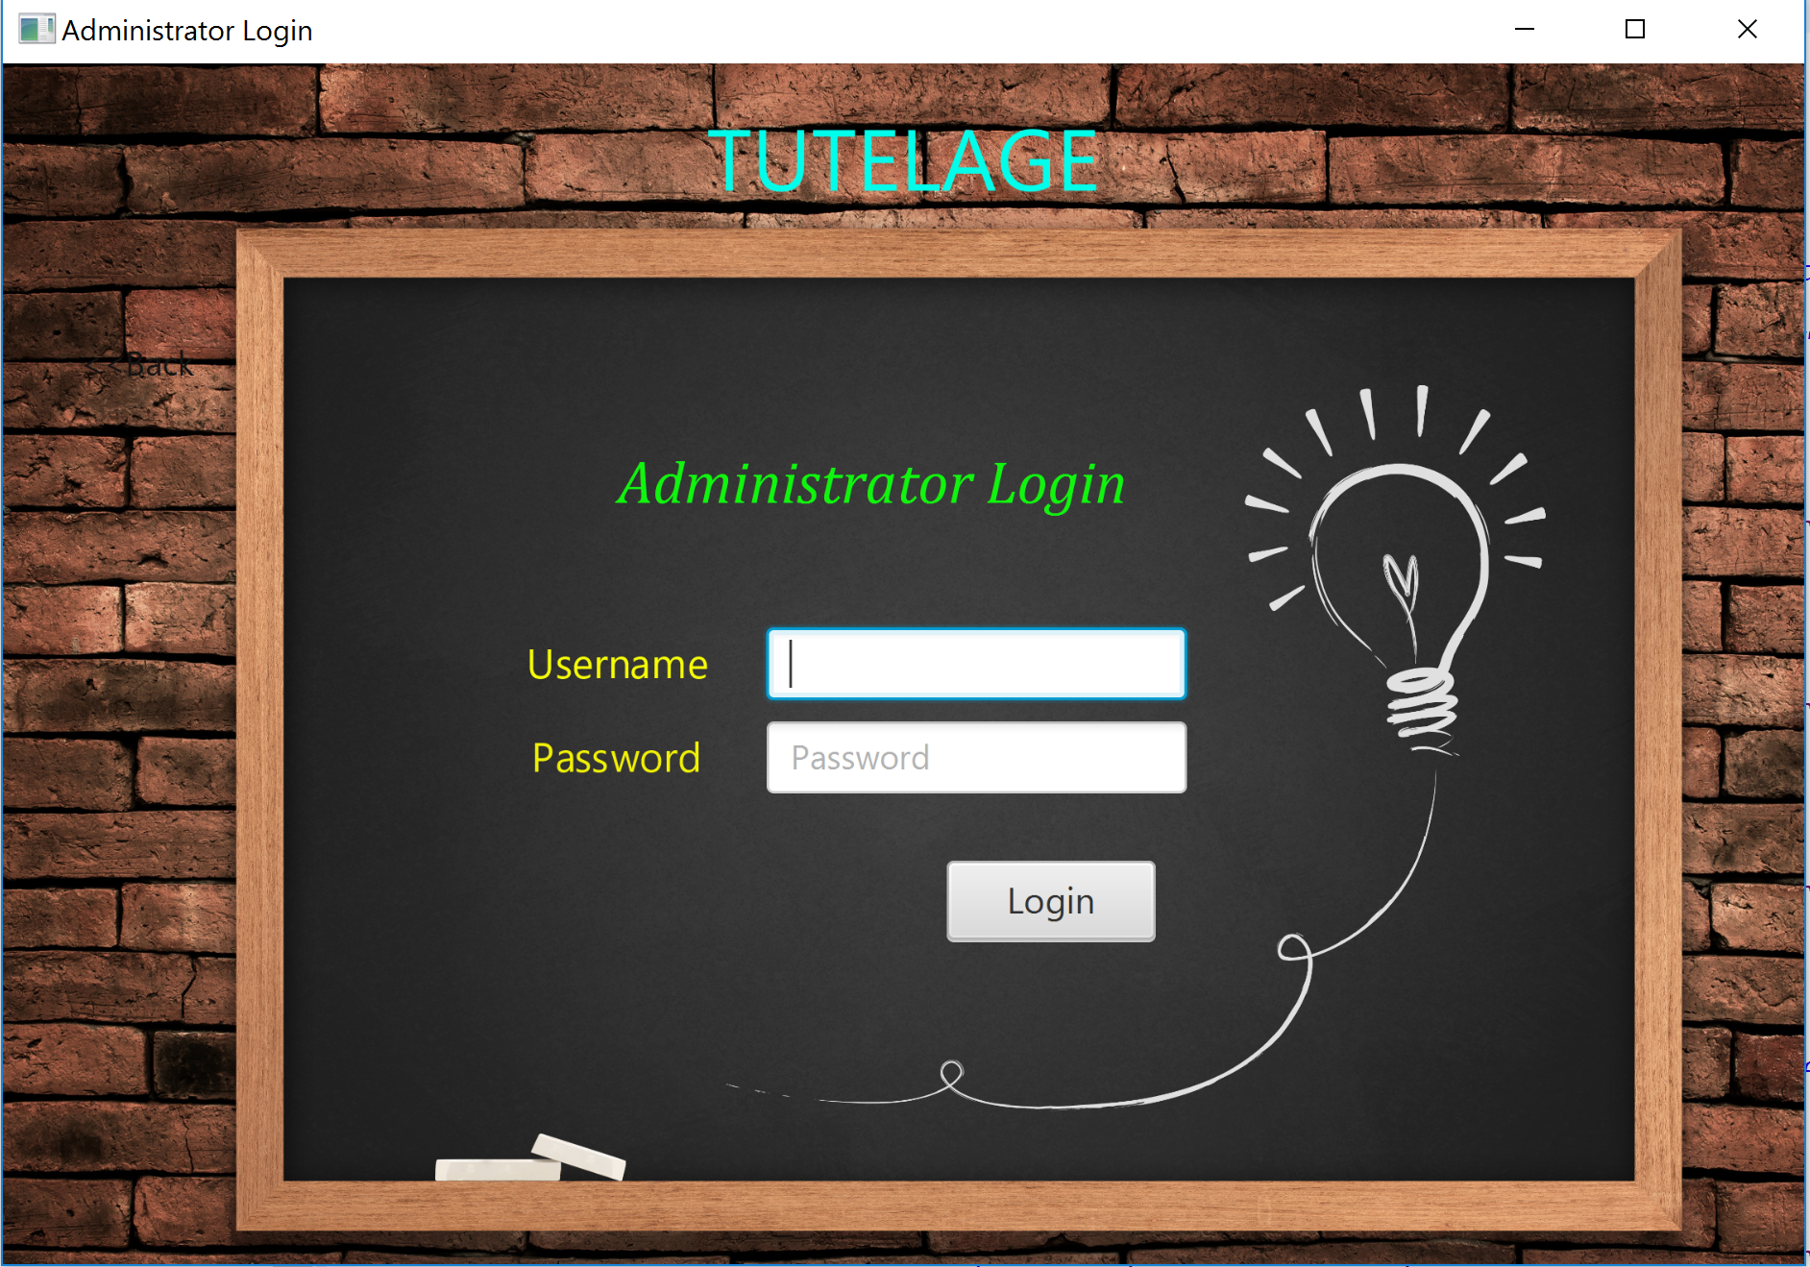

**1.2 PROFESSOR LOGIN:**

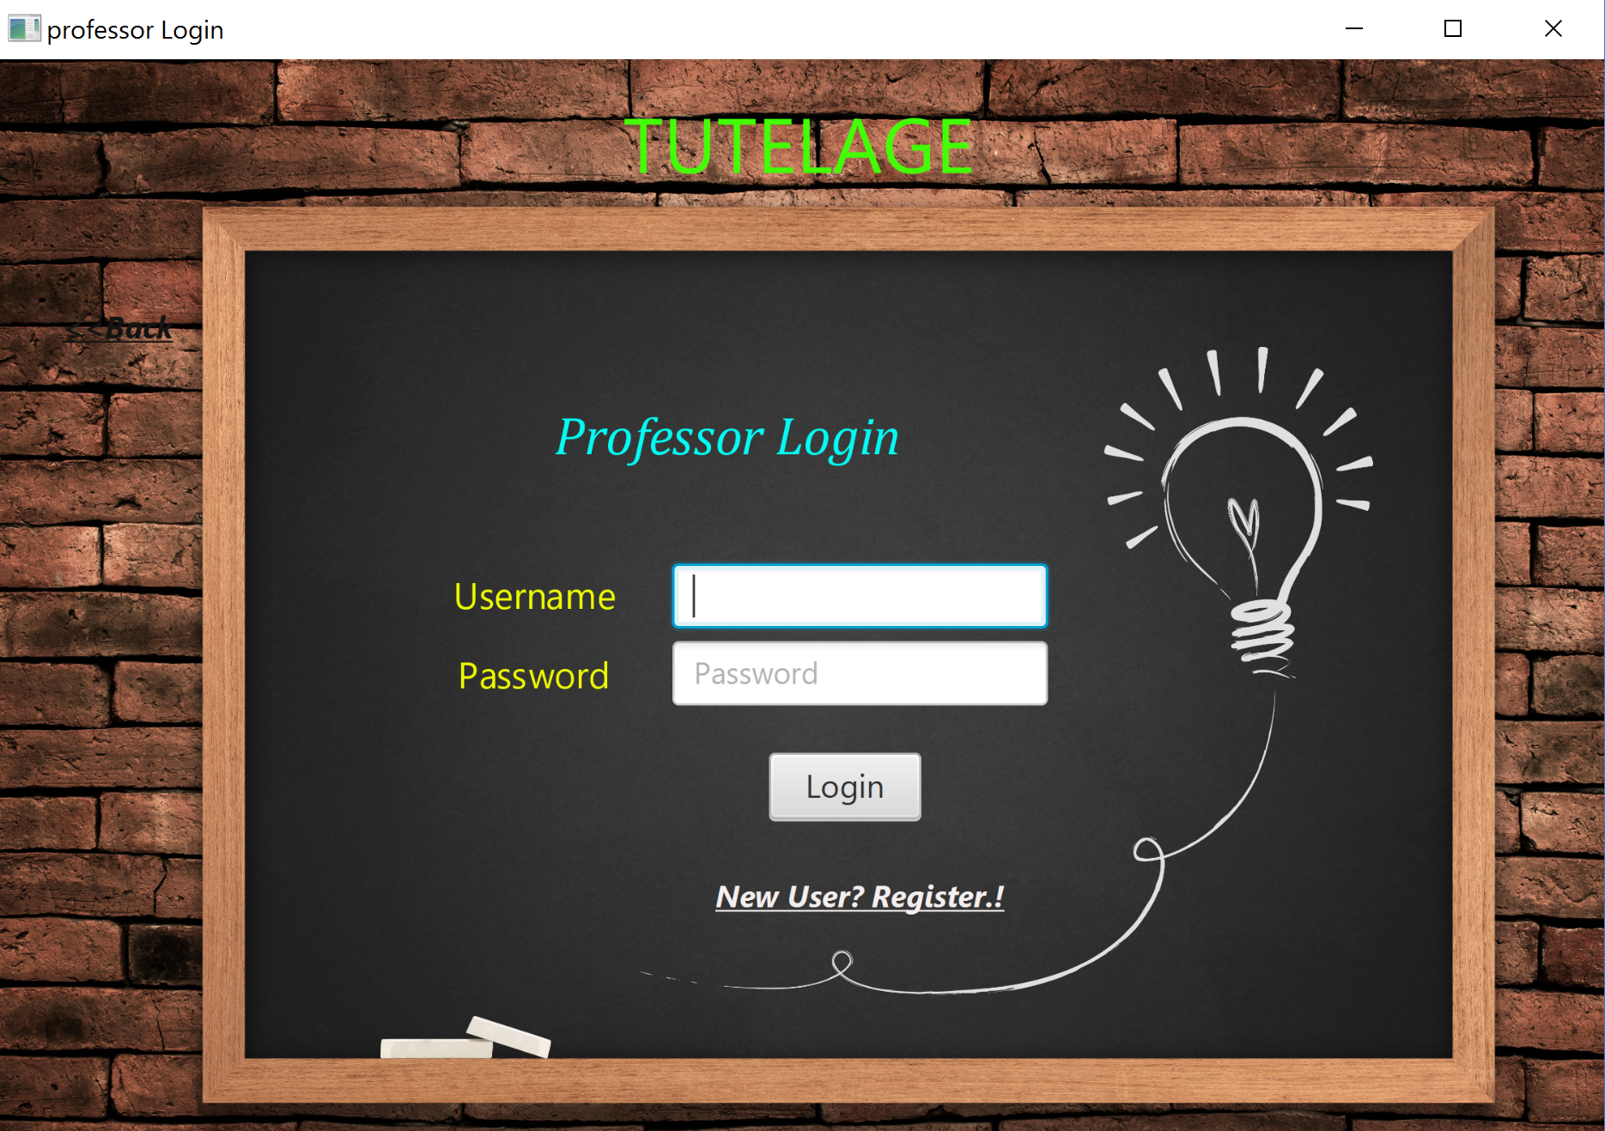

**1.3STUDENT LOGIN**

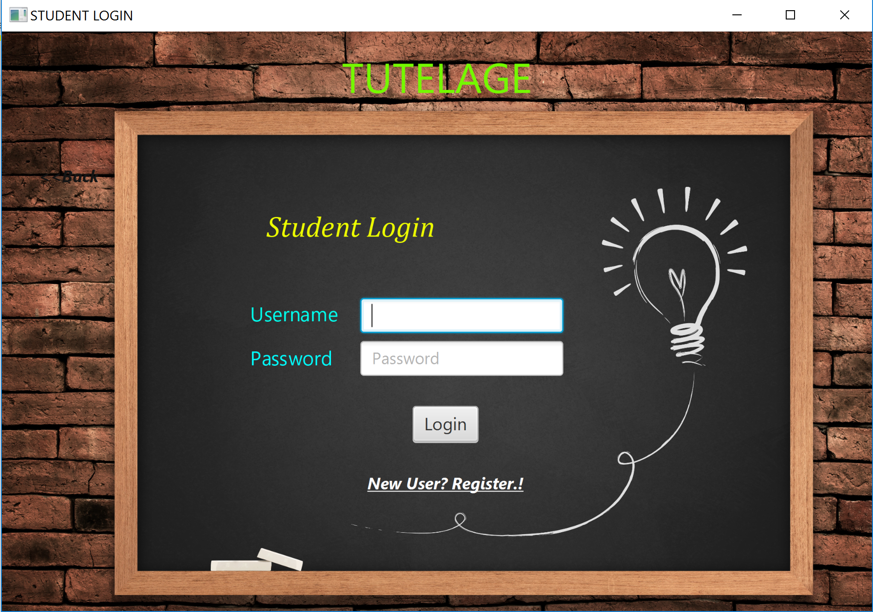

**1.4 REGISTRATION PAGE:**

**STUDENT/ PROFESSOR REGISTRATION PAGE:**

From the student login page, there is a link for registration page if the student is logging in for the first time.

Similarly, from the professor login page there is a link for the professor to register if he is logging in for the first time.

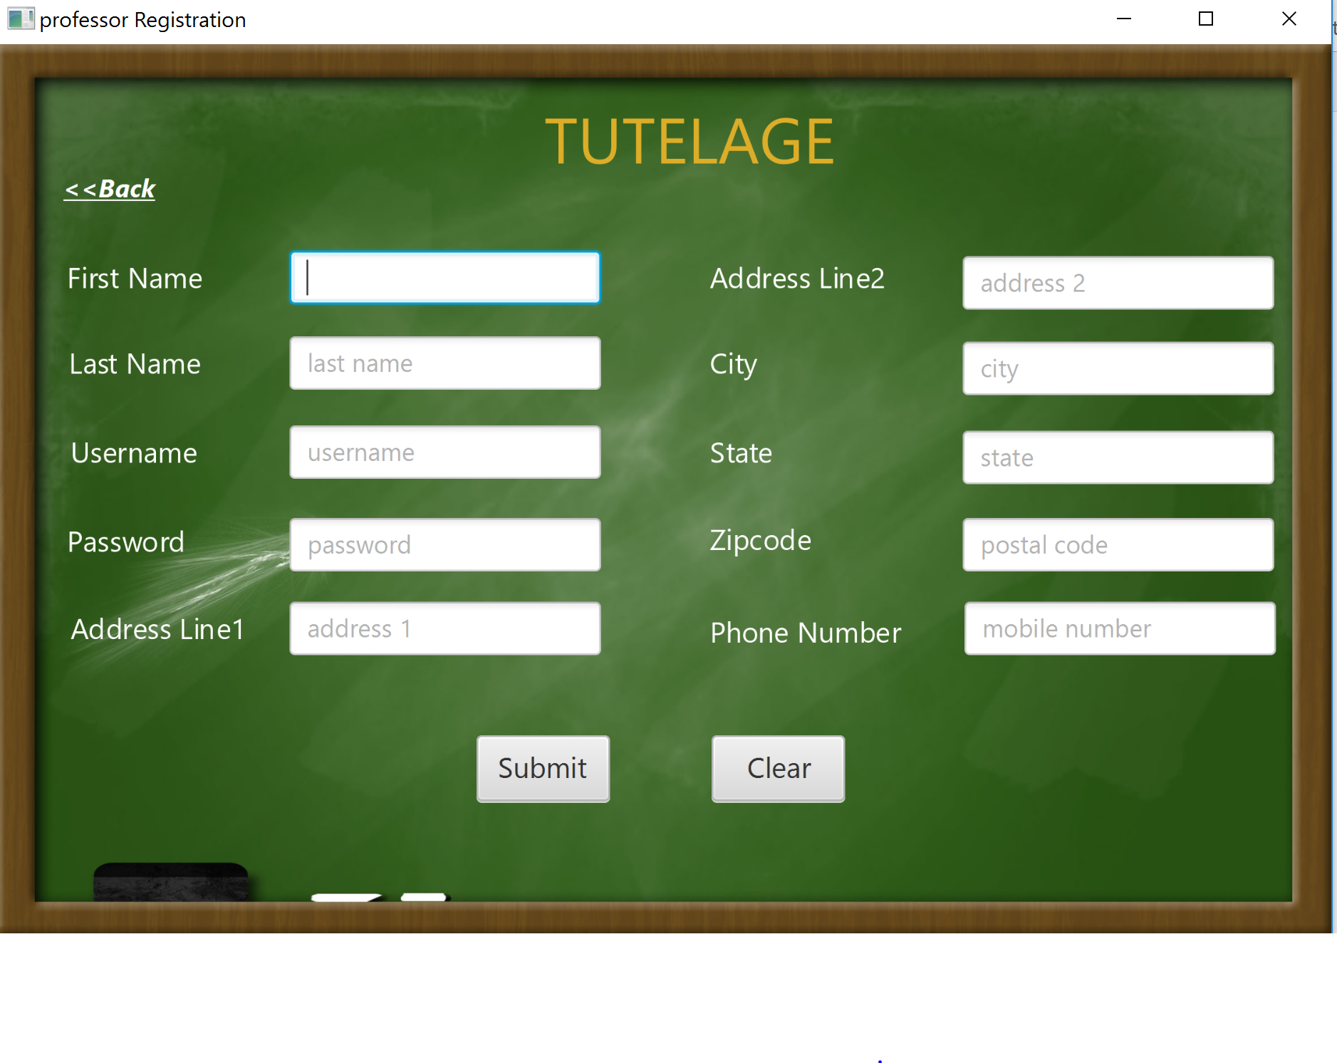

**2 ADMIN PAGE BEGINS HERE**

**2.1 ADMIN HOME PAGE:**

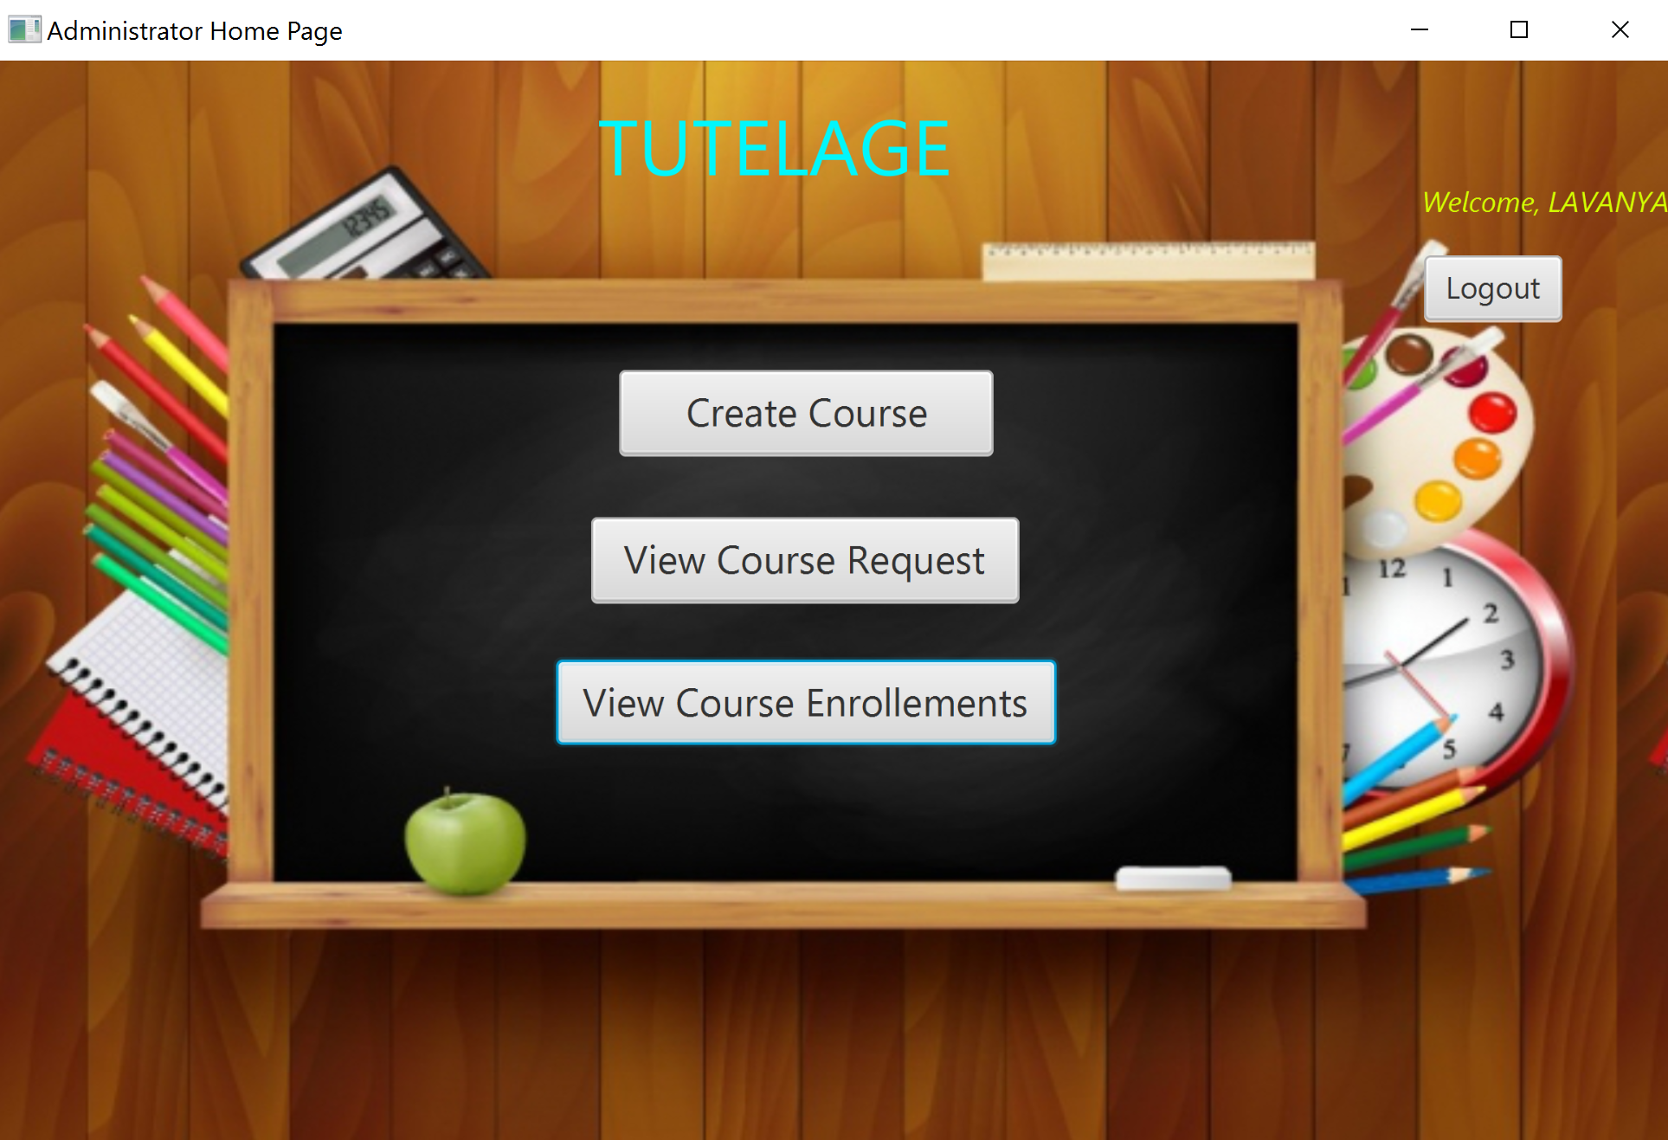

The admin can do the following,

* Create course
* View the list of courses created by him and the courses requested my professor
* Thirdly, the admin can view the list of enrollments for each course, when he clicks view course enrollment.

**2.2CREATE COURSE (FIRST OPTION OF THE ADMIN PAGE)**

This is the page where the admin can create the course.

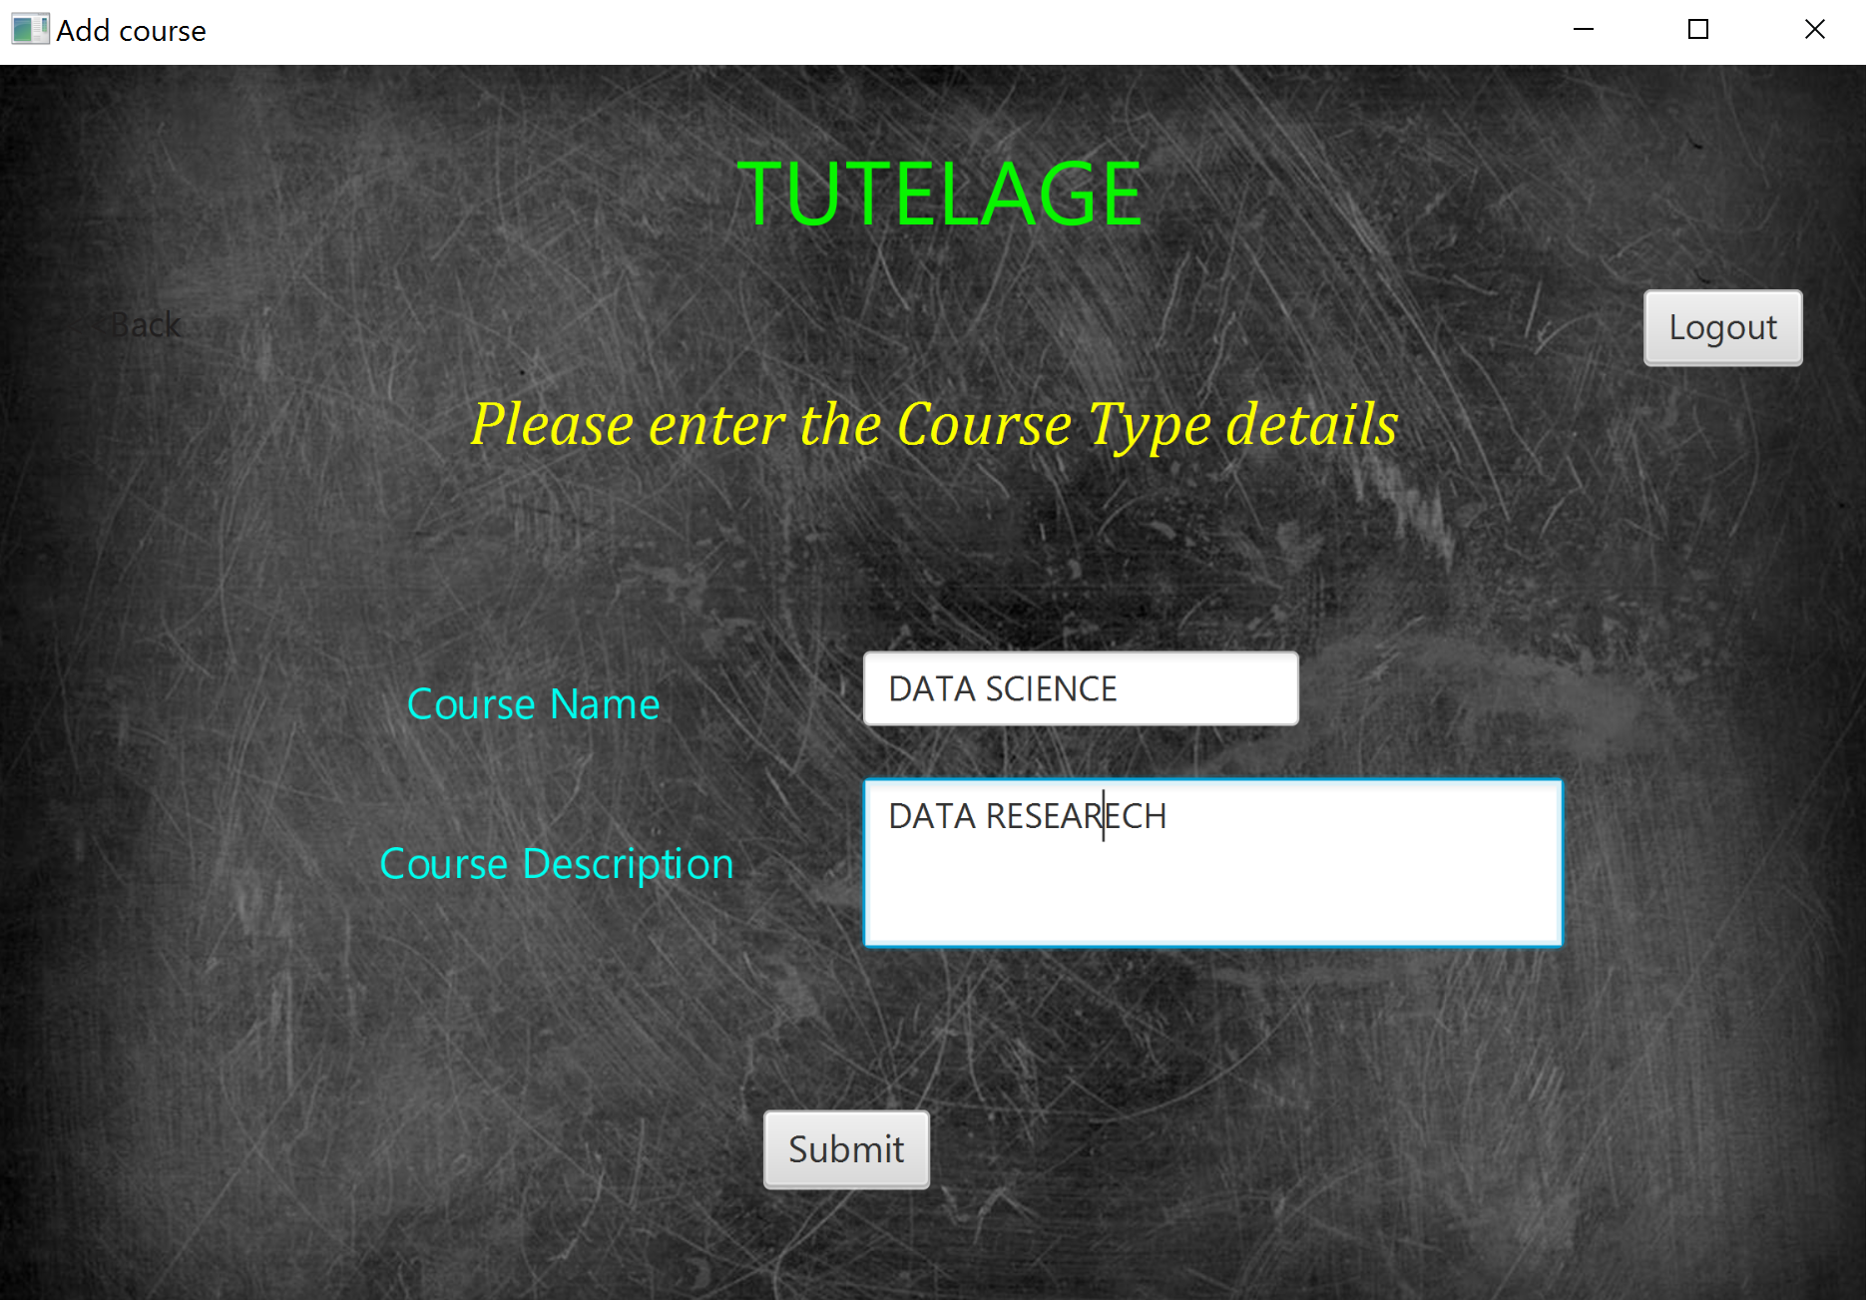

After submitting the user will be notified with the following message**.**

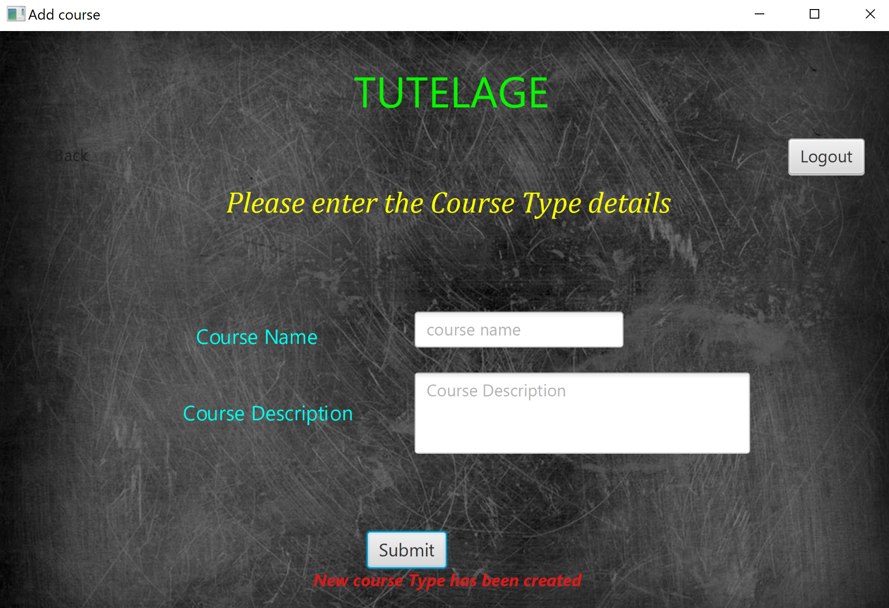

**2.3 VIEW COURSE REQUEST(SECOND OPTION OF THE ADMIN PAGE)**

This page will list the various courses listed by professor as well as admin

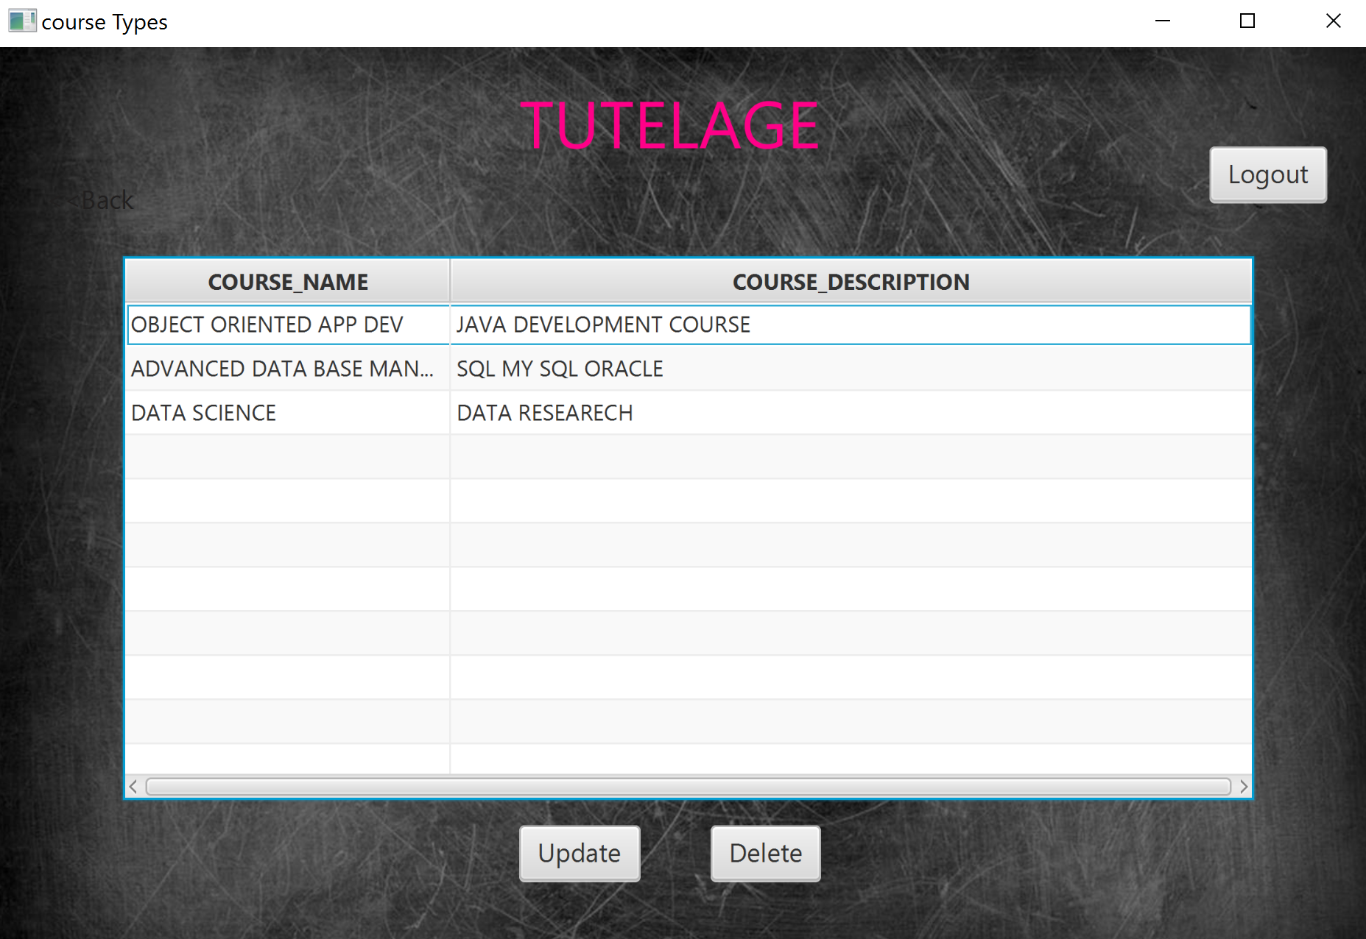

**2.4 COURSE UPDATE:**

The course listed can be updated by the admin, as the following page

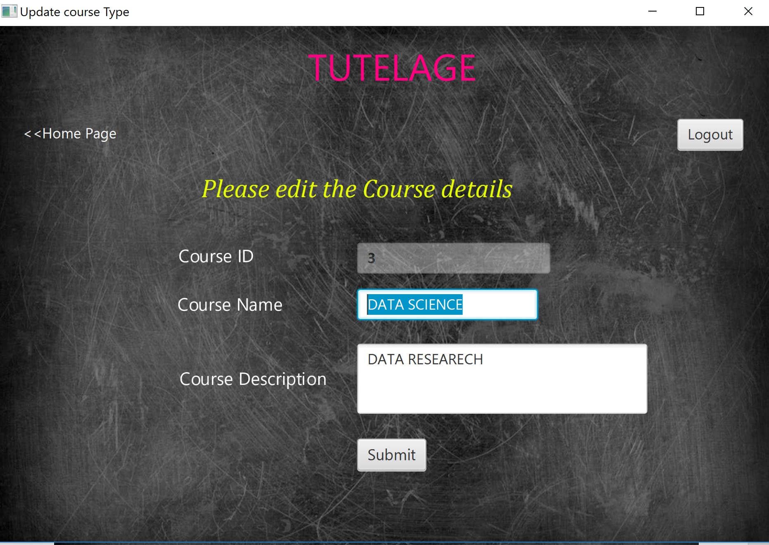

A pop up which denotes successfully updated is followed by when the course is updated (below picture)

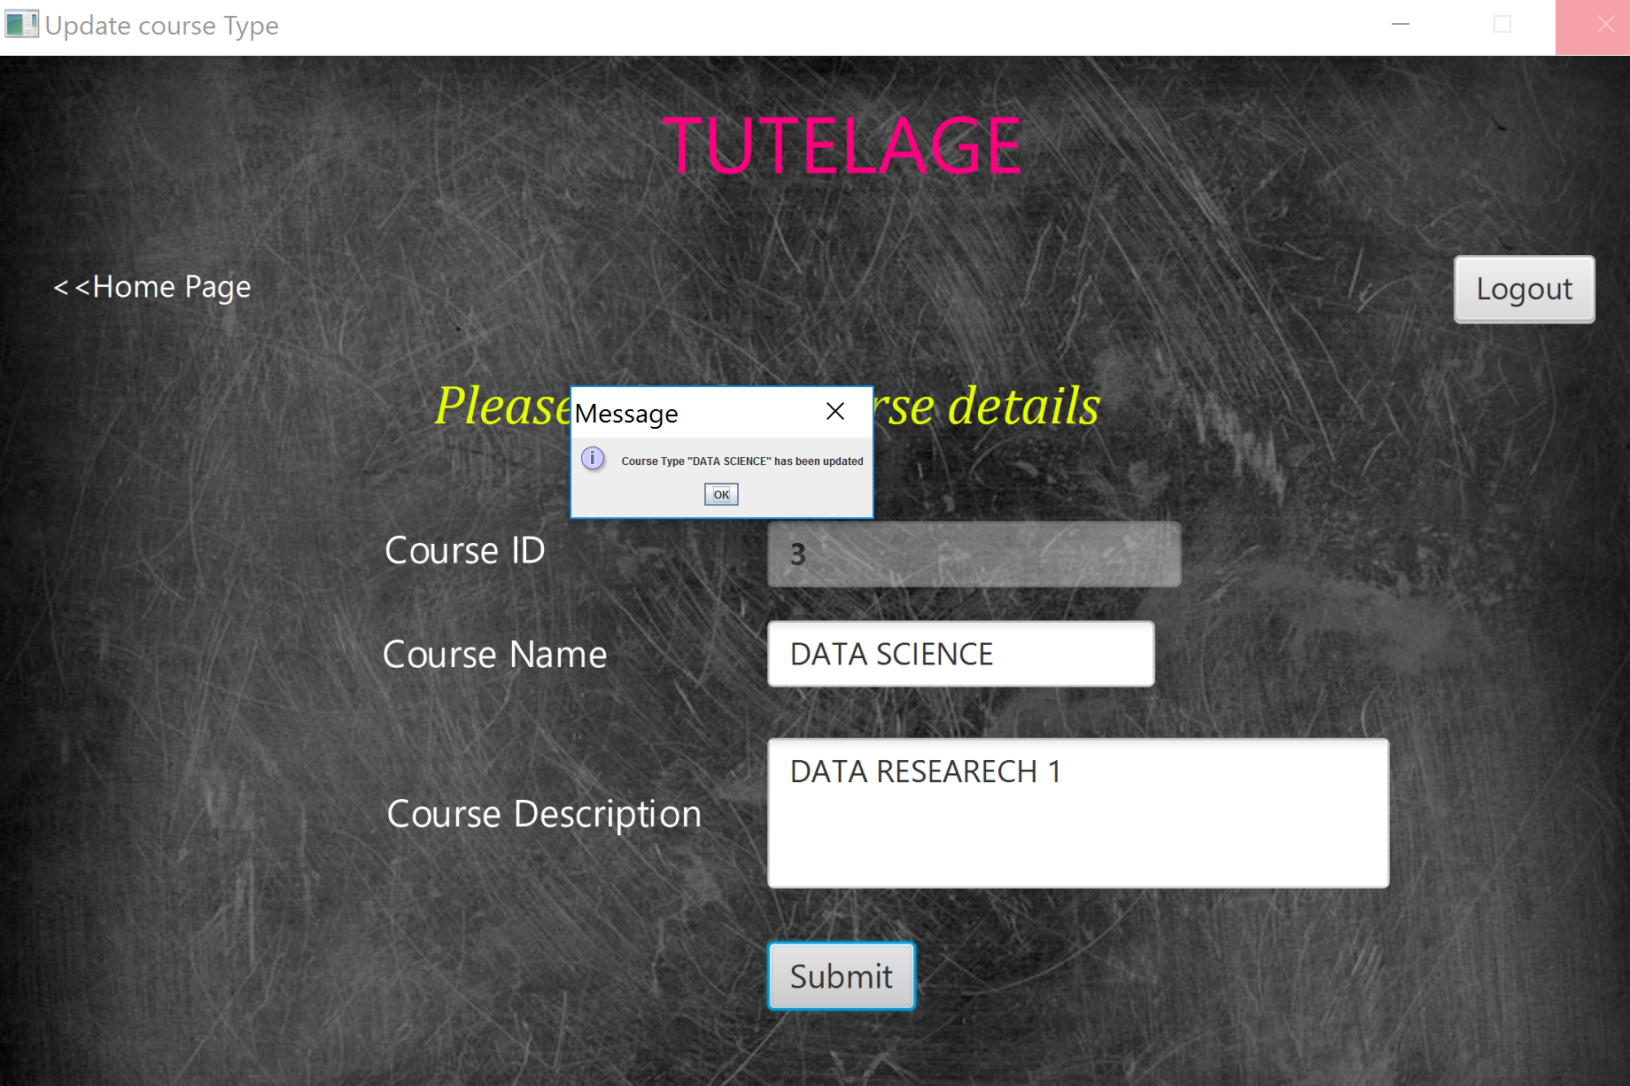

**2.5 DELETE:**

The course listed can be deleted by the admin, as the following page

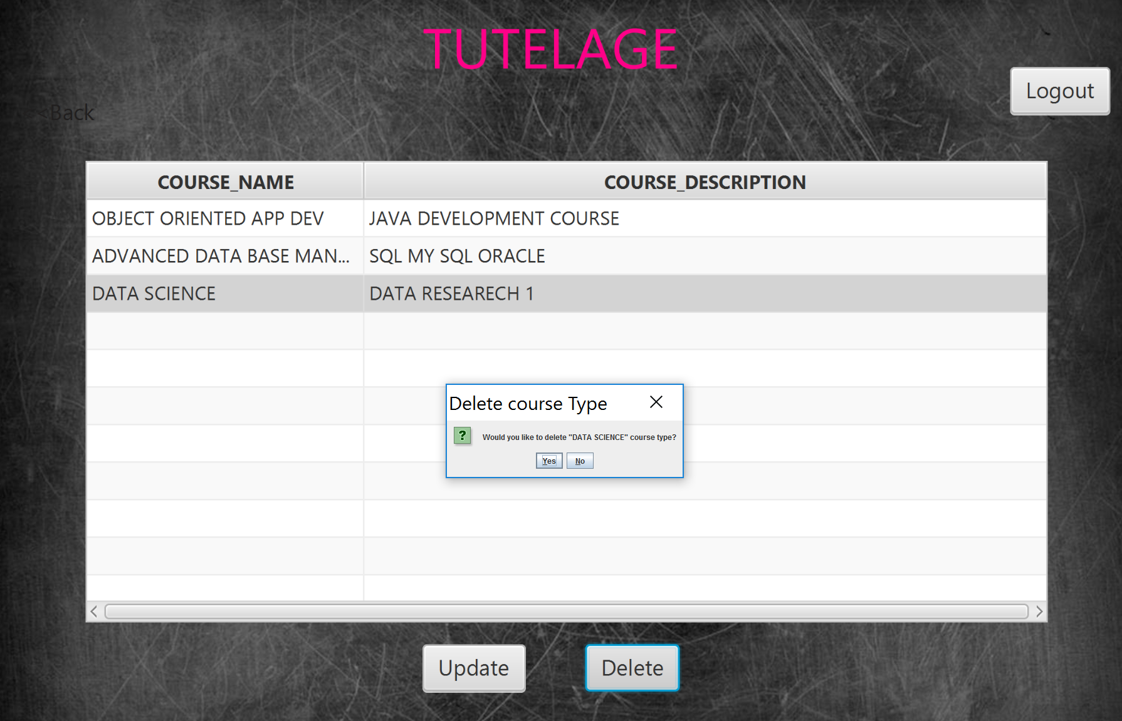

Warning is thrown, if the course has to be deleted

**2.6 VIEW COURSE ENROLLMENT**

This is the most important page of all, which decides whether the course must be taken up or not based on the enrollments

For example: Here in the snap shot the max no of enrollment is for the course **OBJECT ORIENTED APP DEV** as it has **3 students** enrolled for it and hence this course shall be taken up for the semester as it has max no of enrollments. The table also provides the professor who has requested for the course(PROF_SMITH)

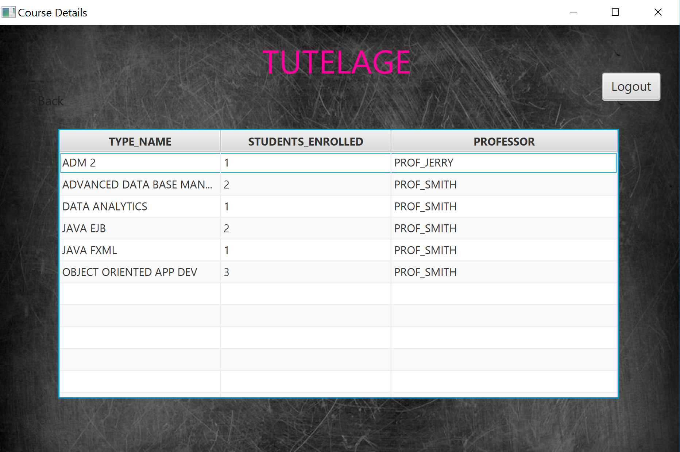

1. **STUDENT PAGES**

**3.1 SUCCESSFULLY REGISTIRED POP UP:**

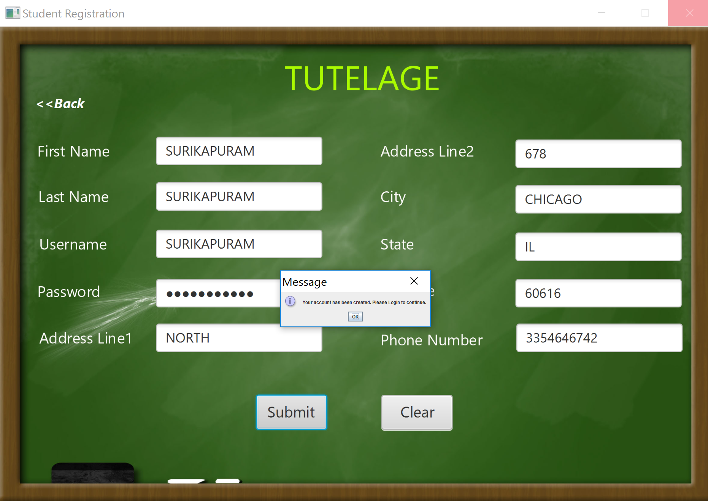

**3.2 STUDENT HOME PAGE**

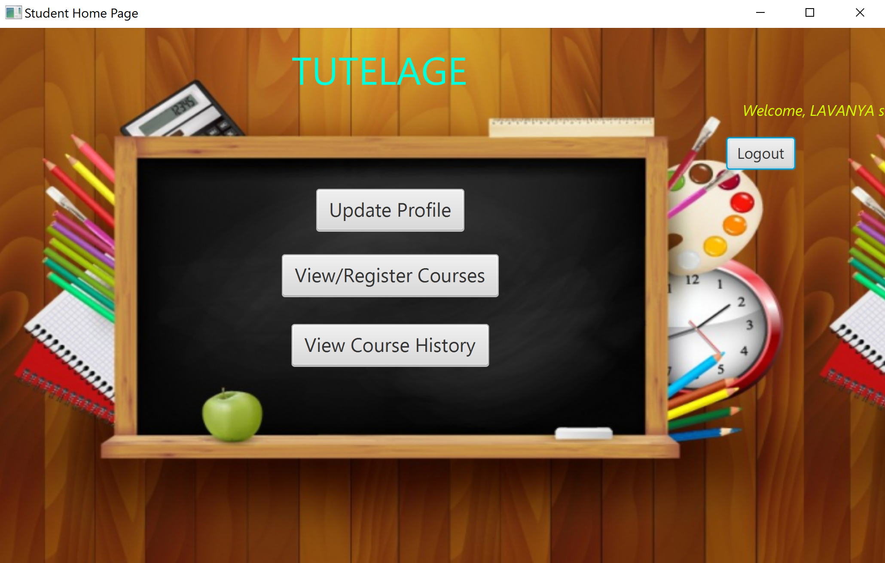

**3.3 UPDATE STUDENT PERSONAL INFO PAGE:**

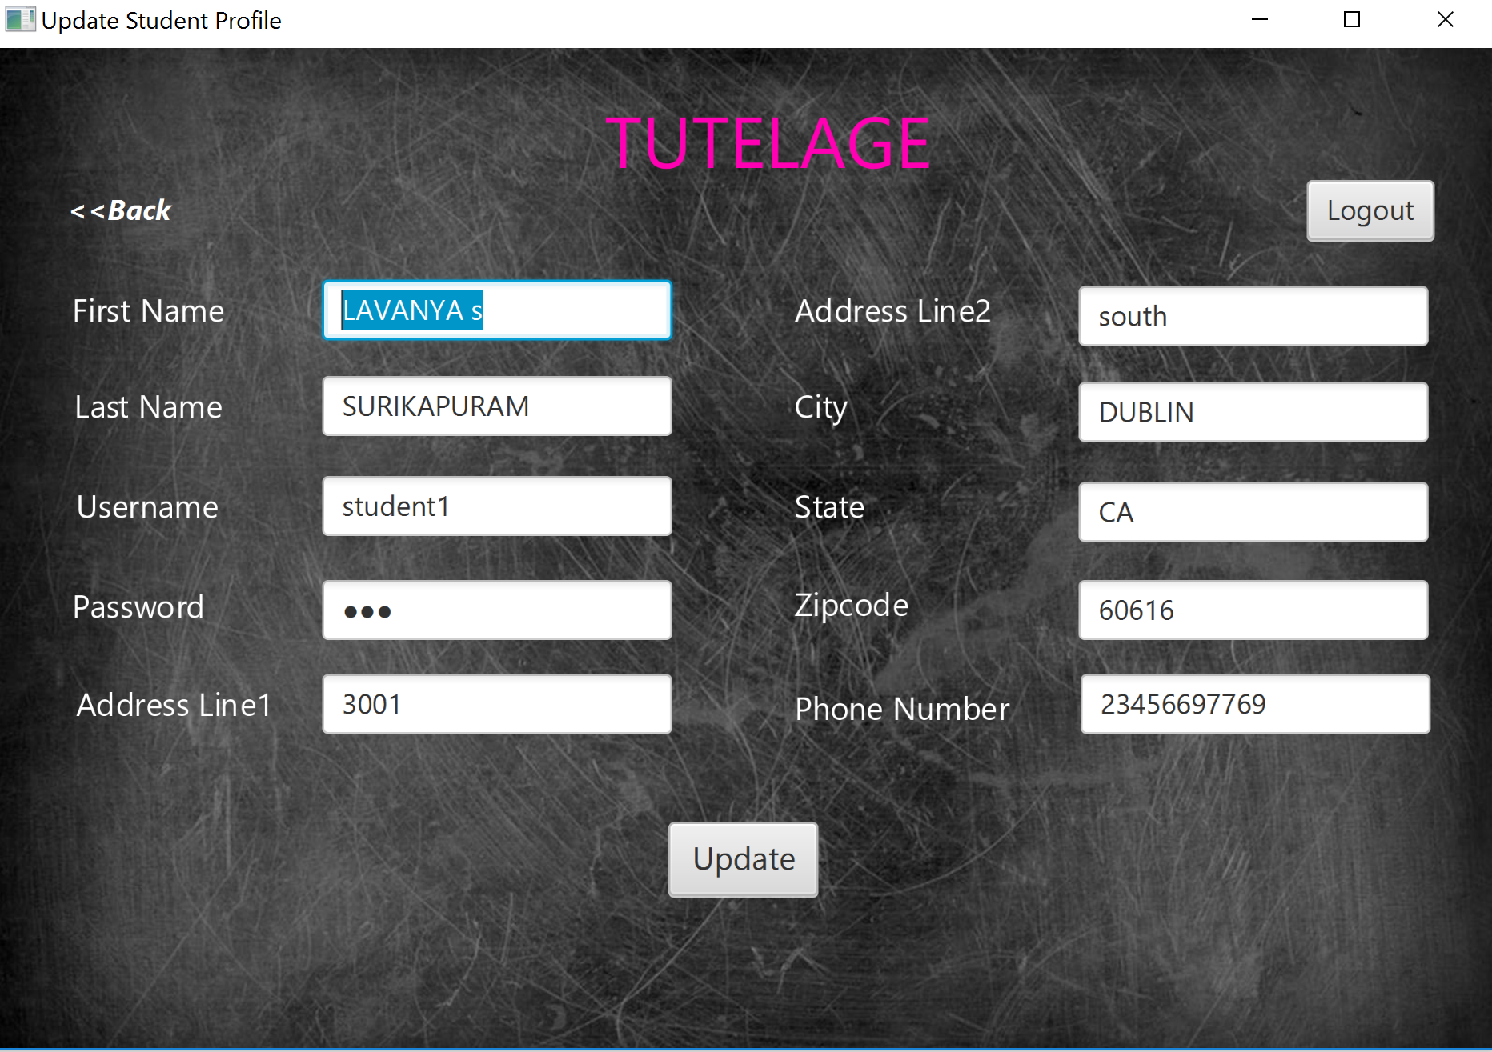

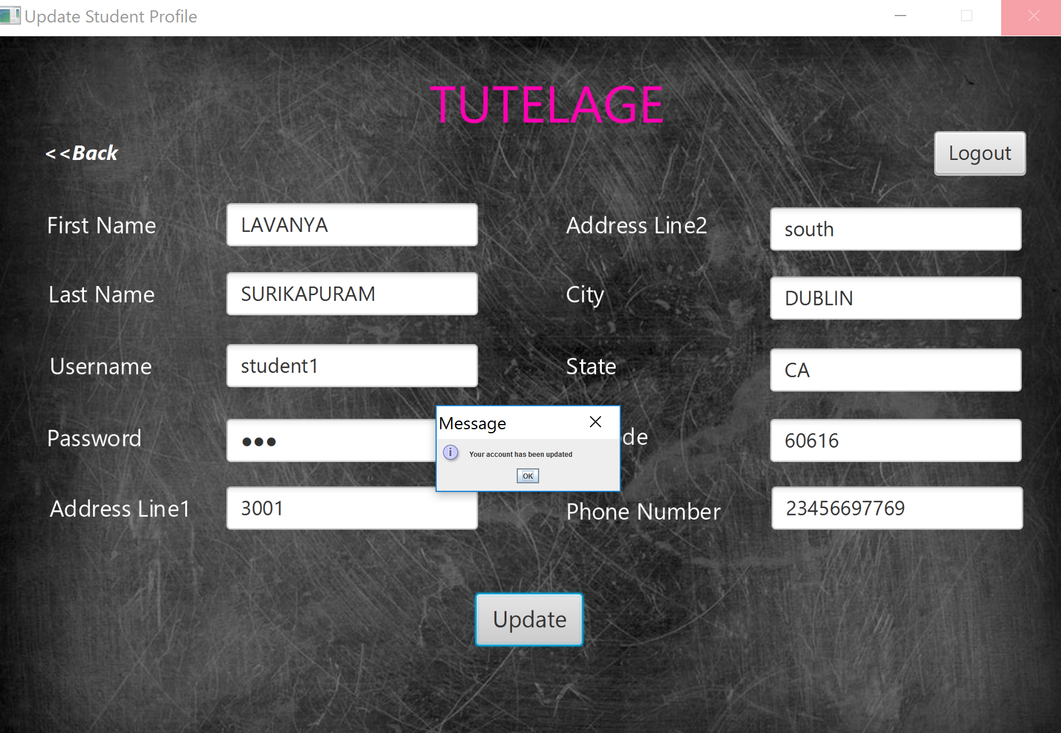

* 1. **Course registration page of the students(2ND OPTION):**

Students can select the course listed by the professor and register It

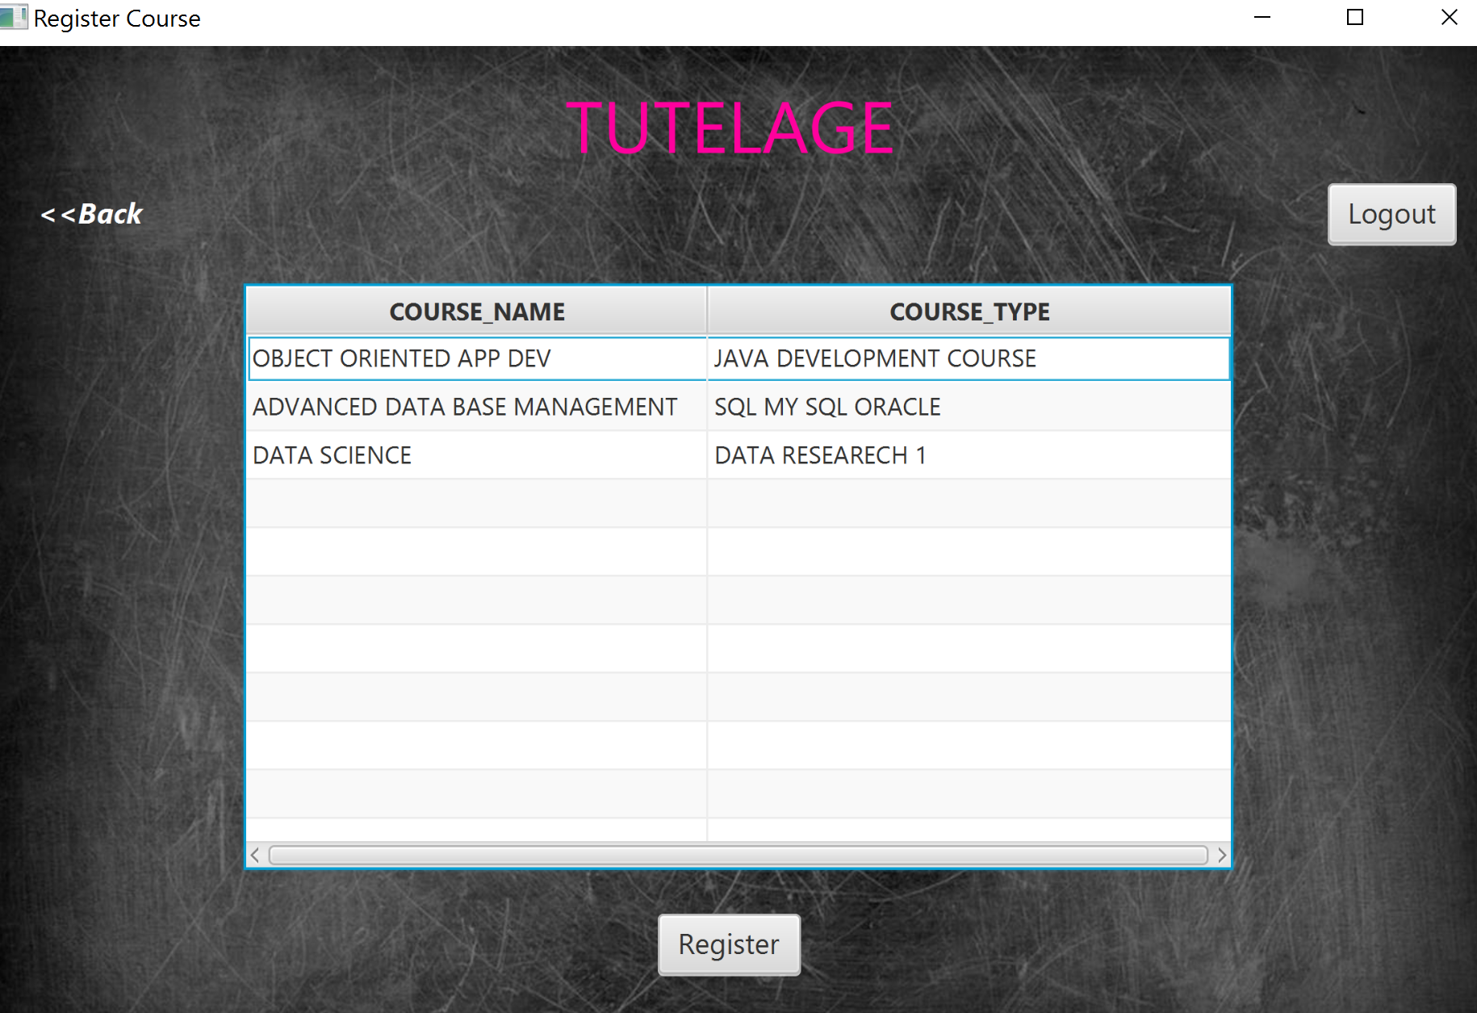

* 1. **SUCCESSFULLY REGISTERED POPUP:**

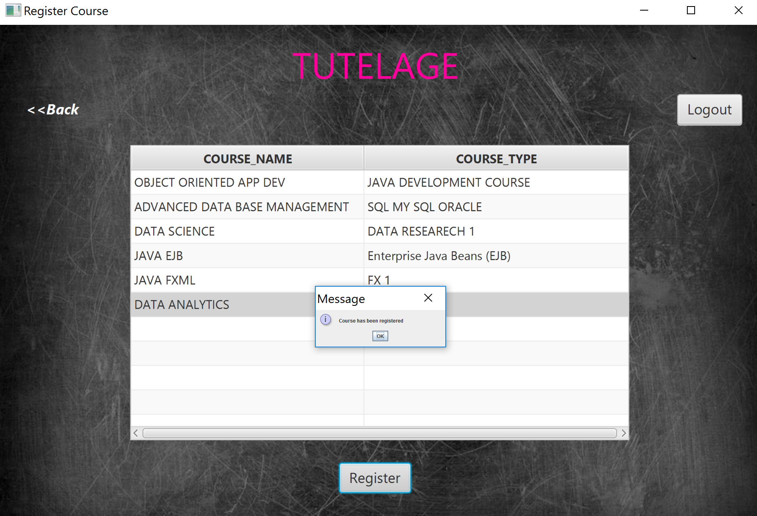

**3.6 Registered course history(option 3 under students):**

They can view the courses they registered for

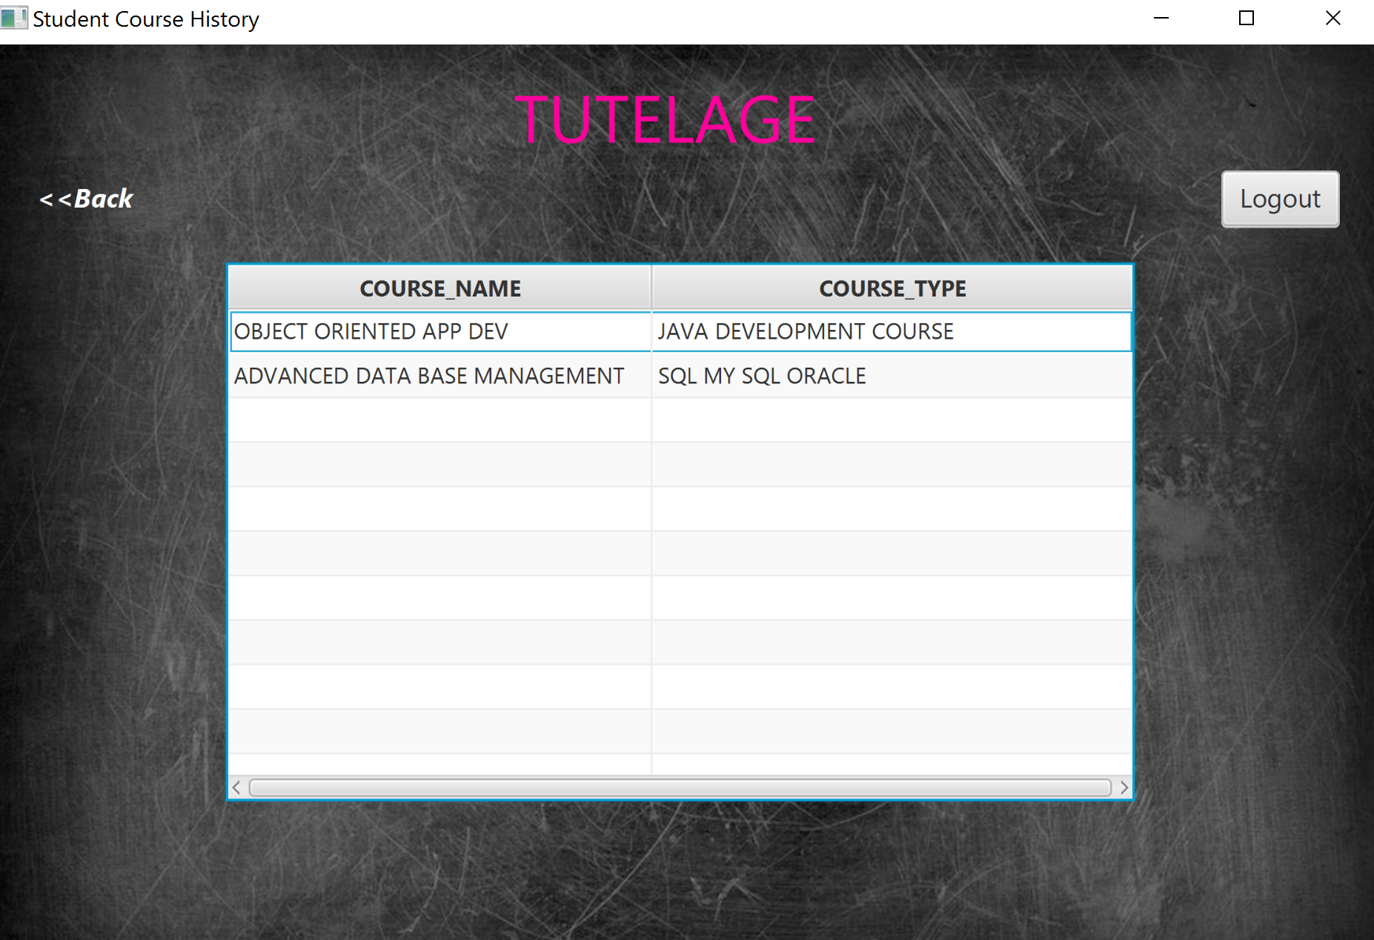

**4 PROFESSOR PAGES**

* 1. **SUCCESSFUL PROFESSOR REGISTERATION:**

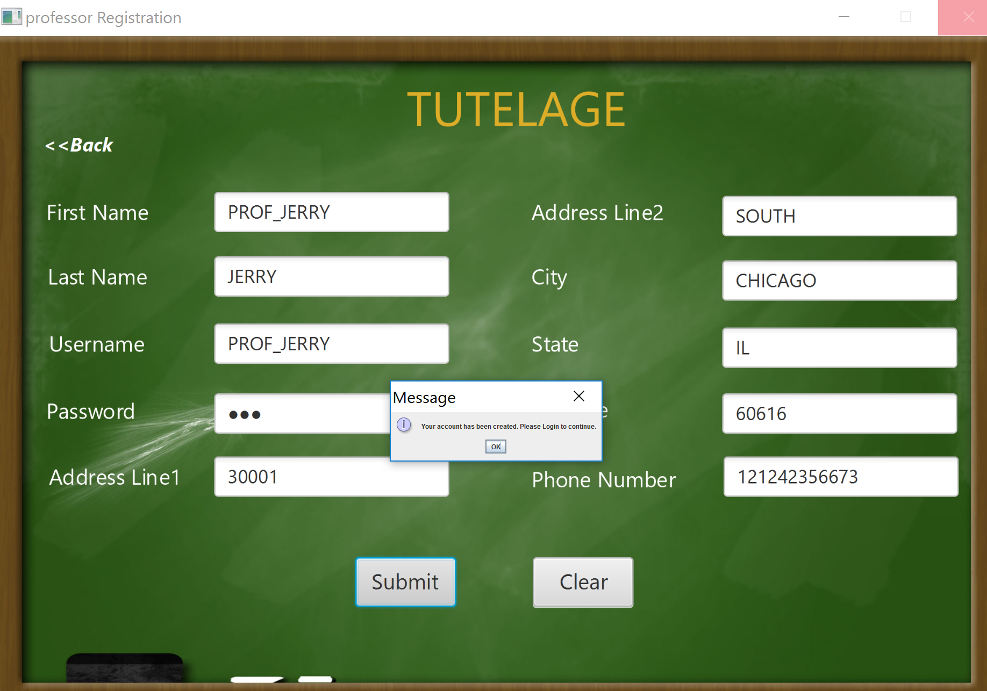

* 1. **PROFESSOR HOME PAGE:**



* 1. **PROFESSOR FIRST OPTION(UPDATE PERSONAL INFO)**

THE PIC ABOVE SHOWS THE SUCCESSFUL UPDATION OF PERSONAL INFORAMTION.

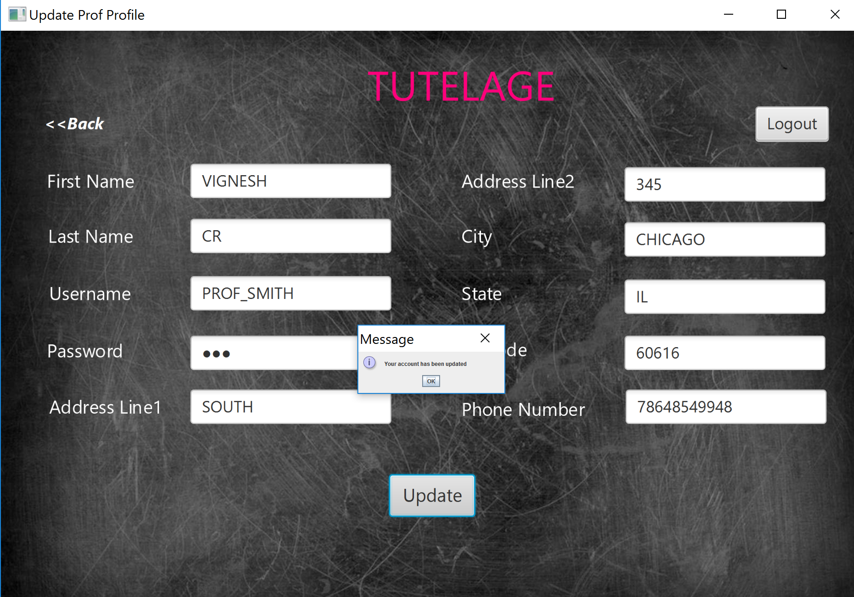

* 1. **PROFESSOR REQUEST COURSE(SECOND OPTION IN PROFESSOR HOME PAGE):**

Once the submit is clicked this pop up appears.

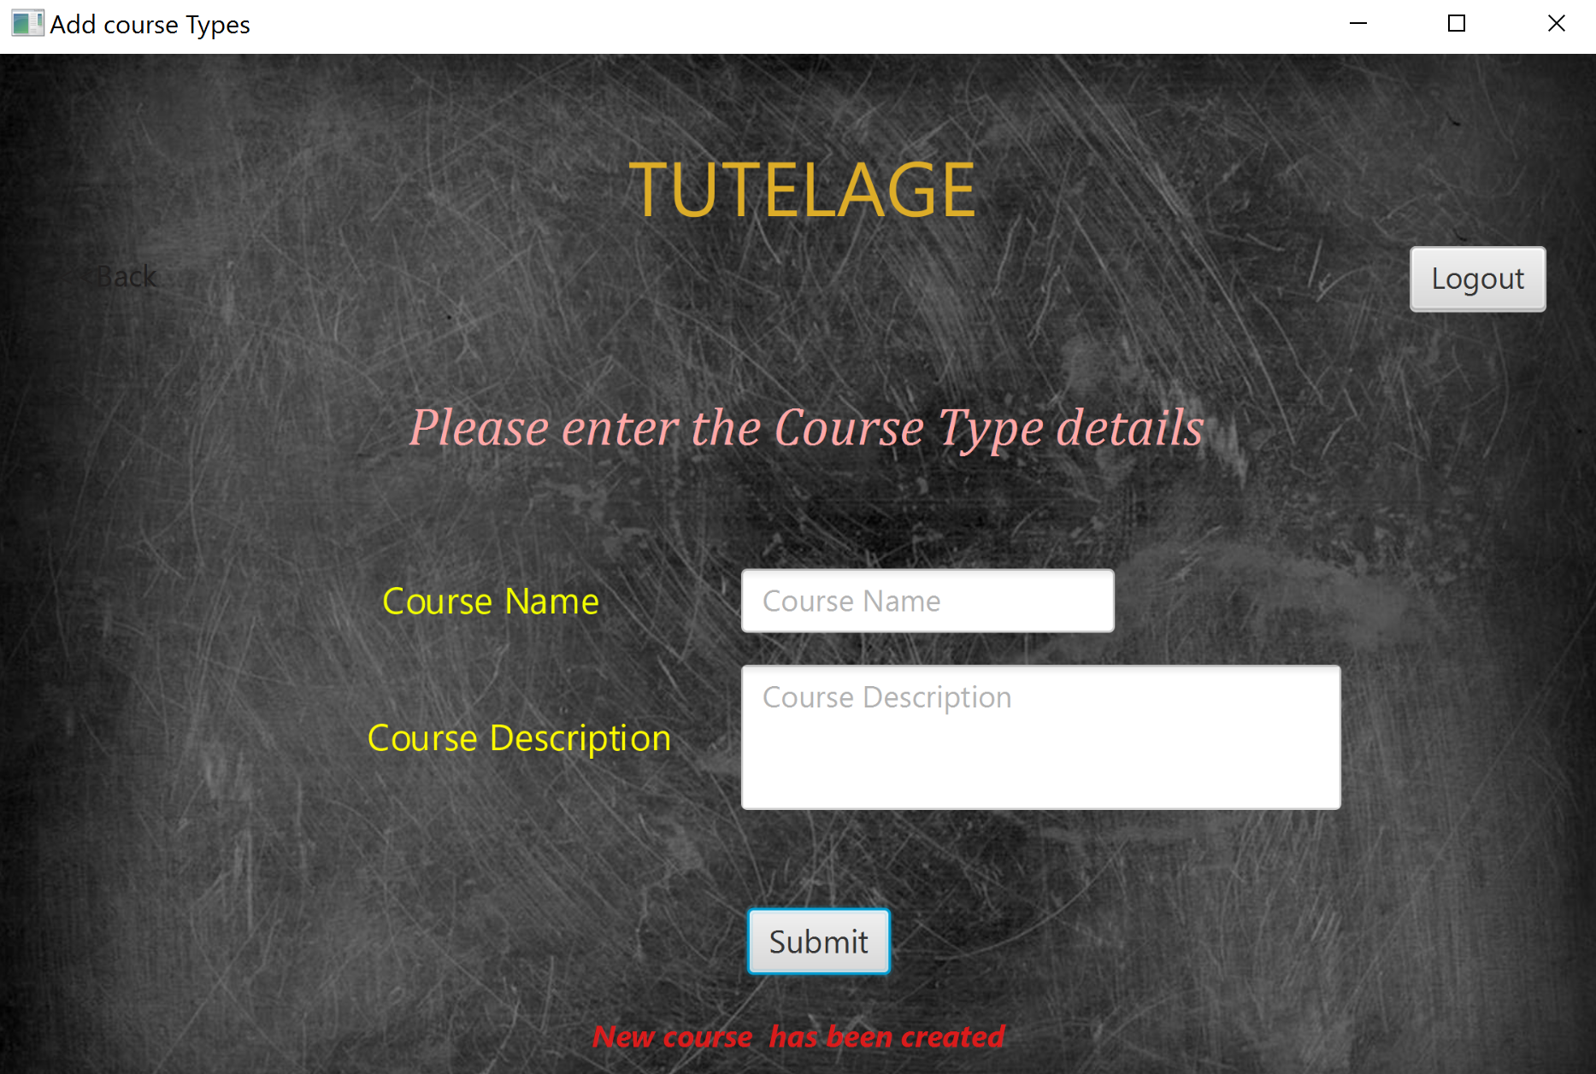

* 1. **View of requested courses:**

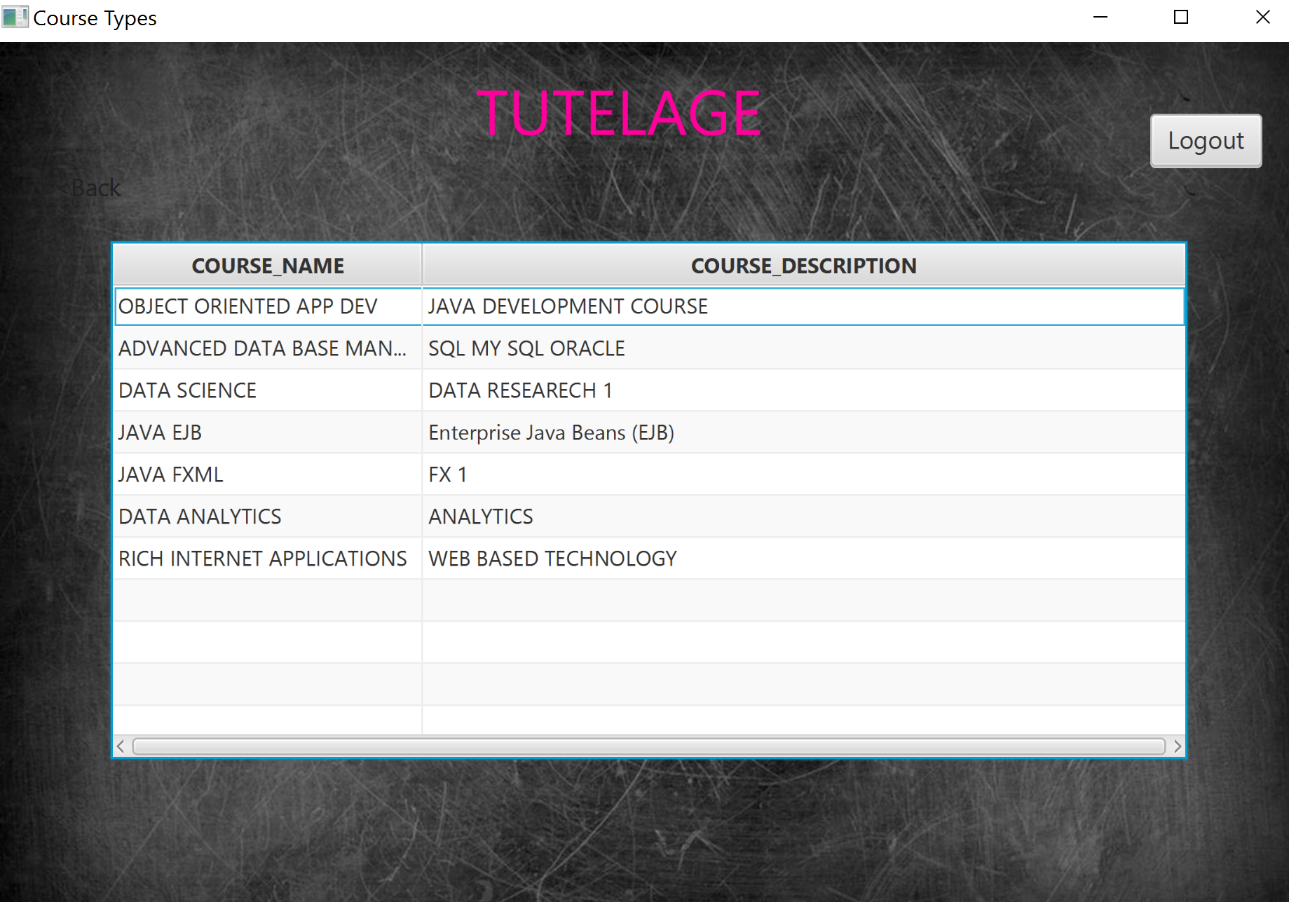

The professor can view the courses he requested for through the third option in the prof home page

**5 ERROR/ VALIDATION:**

**ERROR TRAPPING FOR LOGIN:**

**5.1 PROFESSOR LOGIN ERROR:**

If the professor gives submit without entering the any credentials, then this error will pop up

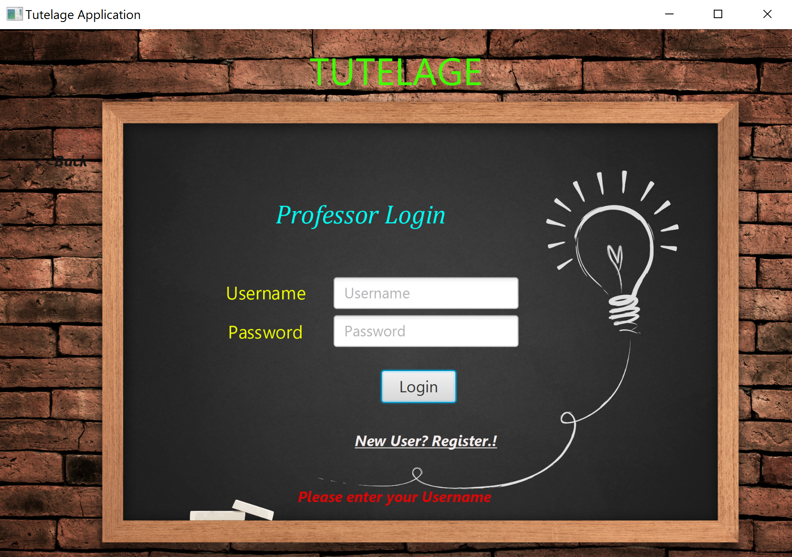

**5.2 FIELD ERROR (SUBMITTING WITHOUT ENTERING)**

WHEN ANY FILED IN NOT ENTERED, THIS POP UP IS THROWN

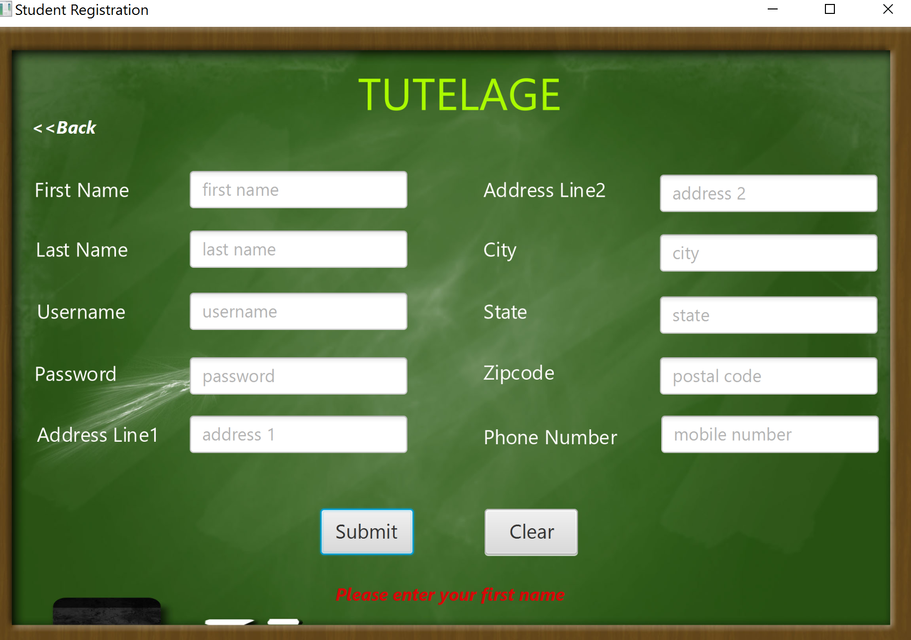

**5.3 UPDATION WITHOUT SELECTION ERROR**

WITHOUT SELECTING THE COURSE AND IF WE GIVE UPDATE, THIS POP UP WILL BE TROWN, SAM EFOR DELETE.

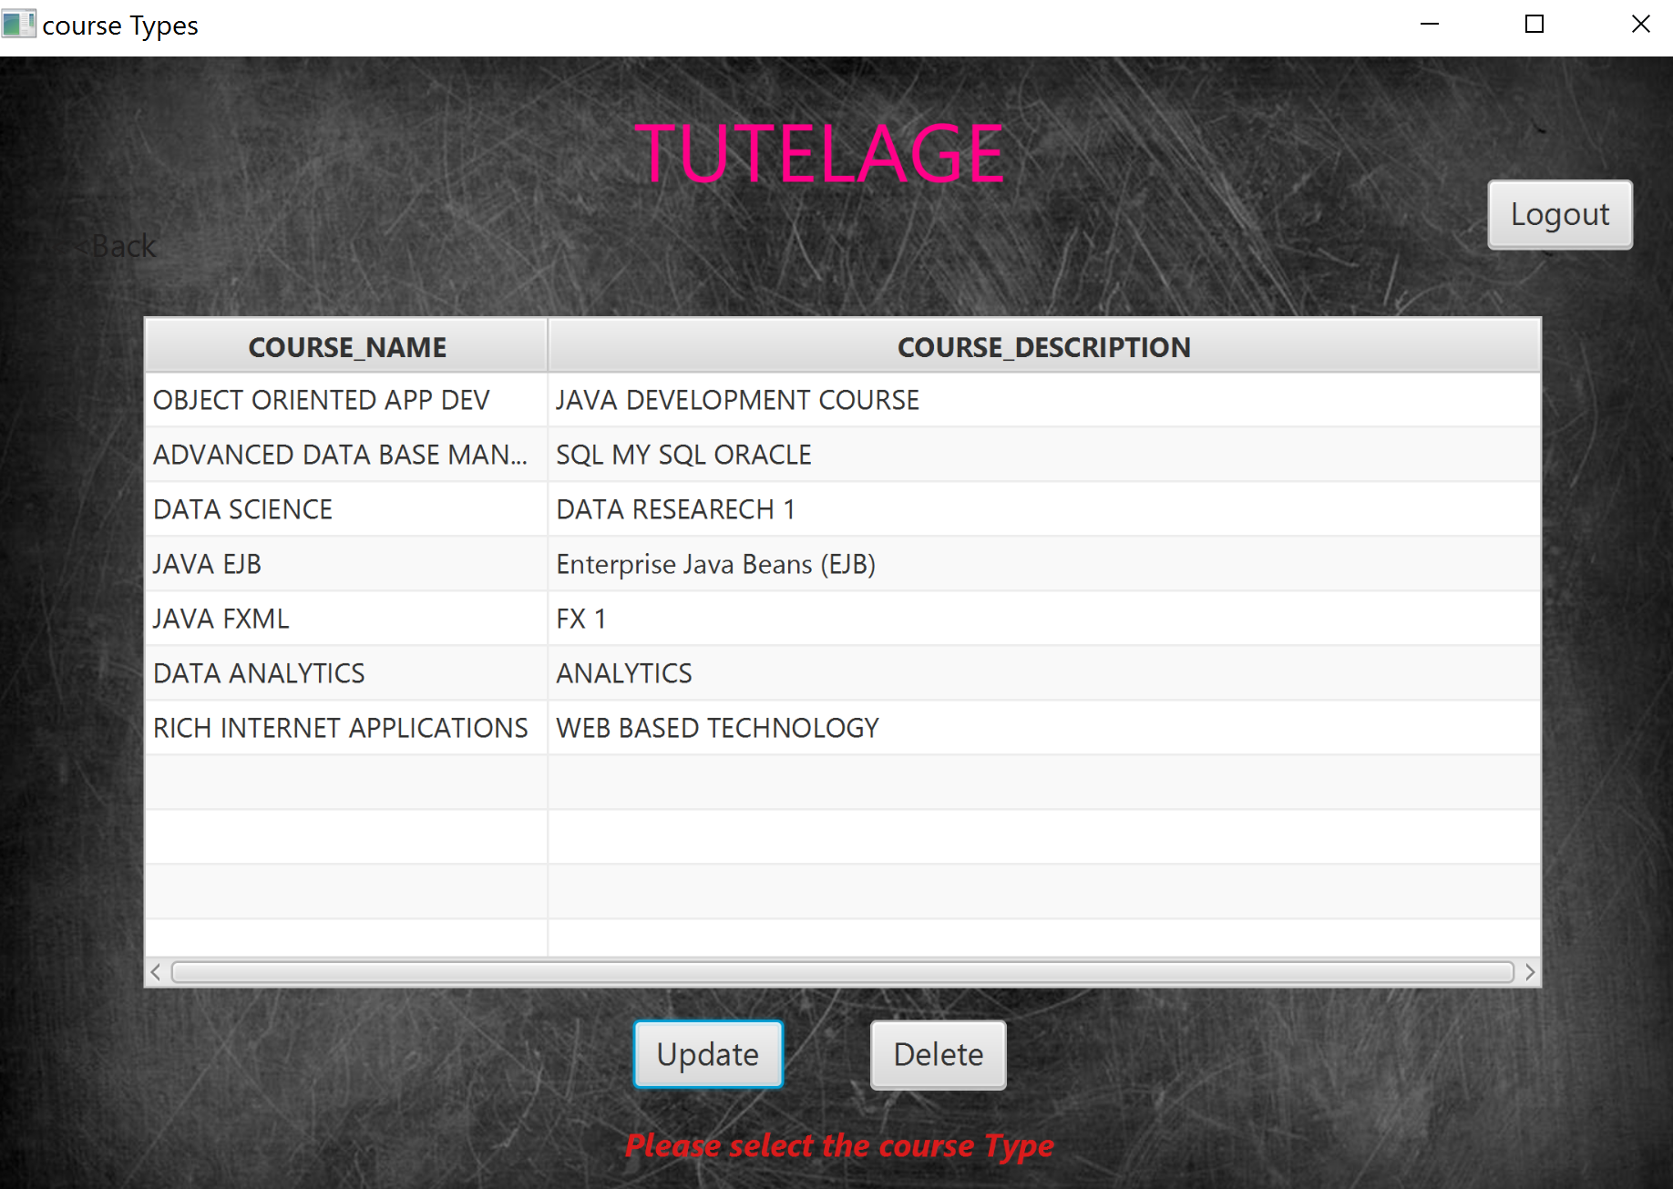

**5.4 VALID INPUT ERROR**

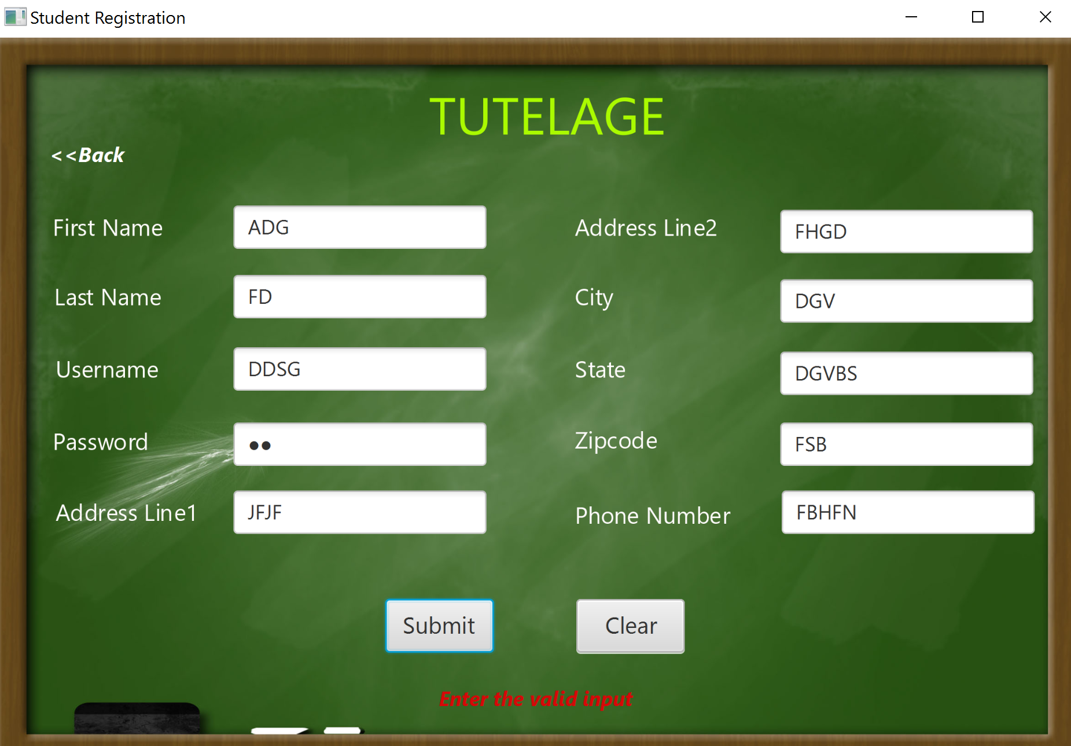

**CREDENTIALS FOR THE PROJECT:**

**ADMIN LOGIN:**

**USERNAME: ADMIN**

**PASSWORD: 123**

**STUDENT LOGIN:**

**USERNAME: IIT_STUDENT**

**PASSWORD: 123**

**PROFESSOR LOGIN:**

**USERNAME: PROF_JERRY**

**PASSWORD: 123**

**EXTRA CREDIT:**

SOLUTION**:**

**CRUD FOR COURSE -> ADDING/ DELETING/ UPDATING/ READING**

**CRUD FOR STUDENT -> ADDING/ UPDATING/ READING**

**CRUD FOR PROFESSOR -> ADDING/ / UPDATING/ READING**